**Team J4 + b:** LA Delay Optimization

Jerry Chen

Jack Wegleitner

John Stuart  
Jules Pommies  
Brian Tam

------------------------------------------------------------------------------------------------------------------

1. Progress that has been made since last week  
2. Goals for the upcoming week  
3. Any problems/difficulties that your group has encountered so far

**1. Progress**

Program

Our team focused this week on debugging the code. After debugging and reducing the sample size to 10 aircraft, our program now compiles. We now have a working program that can handle small sample sizes.

Sample size is limited by our computational memory. When the entire database is used, our program creates a 7 million by 7 million matrix that far exceeds the capacity of a 8GB ram laptop. Looking forward, our goal is to incorporate dynamic programing into our code, as well as other modifications that would make our program run more efficiently. Our goal is to be able to calculate an optimal with the entire data set.

Report

We began to format and compile our final report so that we are not scrambling to write it all in the last week. This includes writing up background information on the 5 LA basin airports and mentioning basic facts such as number of gates and optimal runway capacity. We included our initial figures and pictures of the airports for reference.

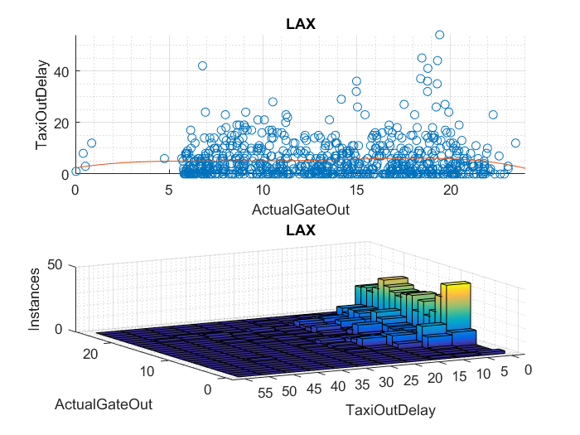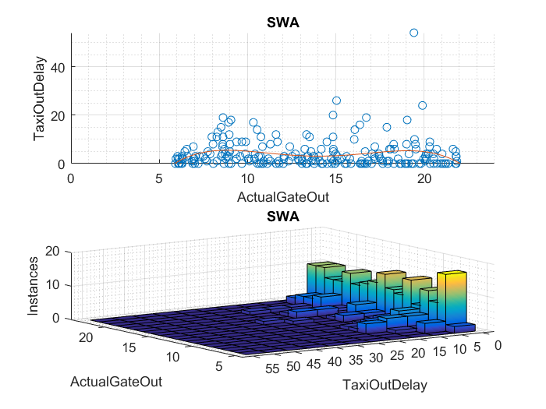

We also began to talk about possible incentives and benefits for airlines and air travelers to convince them to use varying airports throughout the LA Basin.

The code is now compiling but still has issues with time efficiency and will require fine tuning of constraints to produce useable data on a larger and more accurate scale, as well as a way to efficiently determine the weight category of each aircraft.

|  |
| --- |
| LADelay.m |
| ARR=importdata('ARR.csv'); %(flights x data types)  ARRn=ARR.data;  ARRt=ARR.textdata;  DEP=importdata('DEP.csv');  DEPn=DEP.data;  DEPt=ARR.textdata;  start=120; %start analysis of peak hour  sample=10;  N=length(ARRn(start:start+sample-1,1));  R=7;  Rcap=[3; %LAX1 %----additional runway analysis required----  3; %LAX2  2; %LGB1  2; %LGB2  2; %SNA  2; %ONT  2]; %BUR  size = ones (N,1); %create A/C size matrix  %for i=1:N %find the size of the aircraft based on tail number  % if or(strcmp(ARRt(i,3),[TN, TN, TN])); %must be cell array  % Size(i) = 1; %heavy  % elseif or(strcmp(ARRt(i,3),[TN, TN, TN]));  % Size(i) = 2; %B757  % elseif or(strcmp(ARRt(i,3),[TN, TN, TN]));  % Size(i) = 3; %large  % else  % Size(i) = 4; %small  % end  %end  %create matrix of FAA separation regulations based on A/C size  FAAsep=[4 5 5 6; %rows = H->S leading  4 4 4 5; %cols = H->S following  2.5 2.5 2.5 4;  2.5 2.5 2.5 2.5];  T=zeros(N,N);%create minimum headway Matrix T  for i=1:N %create matrix of lead/follow distance relationships between each A/C  for j=1:N  T(i,j)=FAAsep(size(i),size(j))/100;  end  end  %calculate expected air time assuming delays at point of origin and enroute  %time are known. Total airtime represents the expected time of arrival with  %acceptable delays. This program minimizes unacceptable delays in LA airpspace which is  %anything beyond what the airline scheduled for  te= ARRn(start:start+sample-1,2)+ARRn(start:start+sample-1,5)./60+ARRn(start:start+sample-1,17)./60; %te=t_gateOutActual + t_TaxiOutActual + ATe  %ARRerr=te+(1/60)*floor(3*randn(length(te),1)); %Arr = data(:,1) + rand..... random error  M=1e6; % Big M  ncons=(2*N+N*(N-1)+R); %number of constraints  c=zeros(3*N+N*R+N*(N-1)/2,1); %form cost vector  nvars=length(c); % number of variables  c(1:N)=ones(1,N); % minimize sum of delayed arrival times  Tdest= [5 5 10 10 15 5 0;  10 10 10 10 10 0 10;  10 10 5 5 0 10 15;  0 0 0 0 0 10 0]; %time to each destination    ActDest=zeros(N,1); %initialize actual destination  Origin = zeros(N,1);  for i = 1:N  ActDest(i)= 1*strcmp(ARRt(i+1+start,6),'LAX')+3*strcmp(ARRt(i+1+start,6),'LGB')+ 5*strcmp(ARRt(i+1+start,6),'SNA')+ 6*strcmp(ARRt(i+1+start,6),'ONT')+7*strcmp(ARRt(i+1+start,6),'BUR'); %determine original destination  if strcmp(ARRt(i+1+start,5),'orig'); %cell array of eastern origins %determine original direction of origin  Origin(i)=1; %North  elseif strcmp(ARRt(i+1+start,5),'orig'); %cell array  Origin(i)=2; %East  elseif strcmp(ARRt(i+1+start,5),'orig'); %cell array  Origin(i)=3; %South  else  Origin(i)=4; %West  end  end  binCo=[-1 1]'; %most common block of coefficients in A matrix  DelayLim=0;% 10/60; %delay limit for any aircraft in hours  H=1.5/60; %holding pattern length in hours  clear ARR*  Aeq=zeros(2*N+R,length(c)); %initialize Aeq matrix  A=zeros(2*N+R*N*(N-1),length(c)); %initialize A matrix  beq=[zeros(length(te),1);ones(N,1);zeros(R,1)]; %initialize beq  b=[te+DelayLim;-te;zeros(R*N*(N-1),1)]; %initialize b  %% Assemble time constraints  Atcons=zeros(N,length(c));  Atcons(1:N,1:N)= -diag(ones(N,1)); %assemble t components of tcons  %Aeq(1:N,length(c)-2*N+1:length(c)-N)=-H*diag(ones(N,1)); %assemble H components of tcons  %Aeq(1:N,length(c)-N+1:length(c))=-diag(ones(N,1)); %assemble D components of tcons  A(1:N,1:N)=diag(ones(N,1)); %assemble delay limits  for i= 1:N %find additional travel time for change of destination  Atcons(i,N+R*(i-1)+1:N+R*i)= -(Tdest(Origin(i),:)-Tdest(ActDest(i))); %assemble AT portions of tcons for NSEW  Aeq(N+i,N+R*(i-1)+1:N+R*i)=ones(1,7); %assemble single destination constraints for each A/C  end  %A(N+1:2*N,1:N)=-diag(ones(N,1)); %assemble minimum arrival times  A(N+1:2*N,:)=Atcons(1:N,:); %assemble minimum arrival times  %% runway capability constraints  %for r=1:R  %  %end  %% Order Constraint Assembly  MRow=1; %start with first pair of Big M constraint rows (Mcons)  for i=1:N %assemble t components of all time interval constraints (tcons)  for k=1:N  if i>k  Tco=[T(i,k);T(k,i)];  A((2*N+2*R*(MRow-1)+1:2*N+2*R*MRow),i)=repmat(binCo,[R,1]); %assemble t components of Mcons  A((2*N+2*R*(MRow-1)+1:2*N+2*R*MRow),k)=-repmat(binCo,[R,1]); %assemble t components of Mcons  A((2*N+2*R*(MRow-1)+1:2*N+2*R*MRow),N+R*(i-1)+1:N+R*i)=blkdiag(Tco,Tco,Tco,Tco,Tco,Tco,Tco);  A((2*N+2*R*(MRow-1)+1:2*N+2*R*MRow),N+R*(k-1)+1:N+R*k)=blkdiag(Tco,Tco,Tco,Tco,Tco,Tco,Tco);  b(2*N+2*R*(MRow-1)+1:2*N+2*R*MRow)=repmat([T(i,k);M+T(k,i)],[R,1]); %assemble order constraints in beq  A(2*N+(2*R*(MRow-1)+1:2*R*MRow),N+N*R+MRow)=M*repmat(binCo,[R,1]);  MRow=MRow+1; %iterate to next constraint set  end  end  end  %for i=1:R*N*(N-1)/2 %Assemble right hand side of Mcons    %end  %% Additional Constraints beyond A and Aeq  holdlim=70000; %set max number of holds  ERdelaylim=10000; %set max amount of en route delay  lb = zeros(length(c),1); %lower bound on all variables  ub = [24*ones(N,1); ones(N*R+N*(N-1)/2,1);holdlim(ones(N,1));ERdelaylim(ones(N,1))]; %upper bound on all variables  intcon = N+1:length(c)-N; %specify which variables are integer    Sched=intlinprog(c,intcon,A,b,Aeq,beq,lb,ub) %solve MILP  diff=Sched(1:10)-te;  TotalDelay=sum(diff(diff>0)) %Delay |

|  |
| --- |
| Framework for order of arrival constraints using the Big M Method |
|  |

Updated Constraints (added effect of independent runway queues):

|  |  |
| --- | --- |
| Purpose | Constraint |
| Wheels on time equals estimated air time + additional rerouting time + hold delay +approach delay (Aeq) |  |
| Delay limit per A/C |  |
| Single destination constraint |  |
| Minimum headway constraint (inactive for A/C with different destinations) | equation preview |
| Runway capability constraint |  |

**2. Goals**

The goal for the next lab is to have a skeleton finalized for our final report structure. Ideally we will have fleshed out the background section of our report and started on filling in the incentives section of our report

Long term goals: Develop a policy strategy for implementation using and output cost data as a baseline for feasibility and magnitude or type of incentives.

**3. Difficulties**

Our difficulties from last week have continued into this week

* Turning tail numbers into weight categories for determining A/C follow times and sequencing in an efficient manner has been difficult. We will look for a solution to this in ASPM and other databases.
* Lack of information on beginning of descent times add a lot of guesswork and assumptions to the estimation of air delays, since it will be difficult to tell how much of the delay is due to terminal airspace congestion and how much is due to outside factors.
* Need a database linking aircraft weight to equipment number

In addition, we are having trouble thinking of concrete benefits for travelers and airlines